
Highcliffe School Student Bulletin
Monday 17th – Friday 21st December 2007: Week A

Thought For The Week:
I will honor Christmas in my heart, and try to keep it all the year. Charles Dickens

News Story of the Week:
Chats in class may help you learn
‘See http://news.bbc.co.uk/cbbcnews/hi/uk/default.stm

On Wednesday 19th December there will be a Cake Sale at break time outside IT3/IT4 in aid of Unicef Inspired Gifts. Come along & pick up a tasty treat!

The Year 10 GCSE Expressive Arts and Dance students will be involved in a workshop with a choreographer all day on Tuesday 18th December. This will take place in the Performance Hall and the Dance Studio.

SCIENCE REVISION CLASSES - YEAR 11 - MODULE 2 AND YEAR 10 MODULE 1. These are running every Wednesday until the exams in January. Please see attached rota. This will also be posted on the Science noticeboard and screens around school. Any questions, please see Mr. Wilson in SC10.

KS4 Booster sessions.  Wednesday. |  | Year 10 Open session, all welcome. |  | Year 11 Open session, all welcome.
19th December ‘07 |  | P1. Ms. Berkeley SC1. |  | C2. Mr Booker SC4.
9th January ‘08 |  | B1. Mrs. Stone SC12. |  | P2. Mr. Evans SC3.
16th January ‘08 |  |  |  | Open. Revision / advice.  Mrs. Johnson SC8.

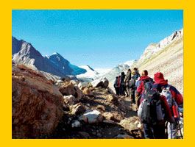
World Challenge Initial Launch Meeting: Thursday 20th December 3:30pm – 4:30pm in the Sixth Form Study Centre
Come along to this launch meeting where the World Challenge contact will be kicking off the fund raising part of the challenge.
If you are still unsure then feel free to come along and see if it helps you make up your mind. You may like to take away some fund raising ideas that you can try over Christmas and see whether you like it or not. Please bring along any completed application forms. See you there. Miss White

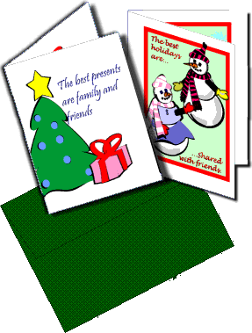
Recycling Christmas card envelopes: when you recieve your Christmas cards, please recycle the envelope in the plastic wallet in your tutor room. The envelopes will be counted after Christmas and the winning tutor group will be announced and presented with a prize in the New Year! Rules: Only Christmas card envelopes accepted.

Science Christmas Quiz: All years. Entry is free. A prize will be given to the KS3 winner and KS4 winner. Multi winners will be placed in a draw. See your science teacher or a technician for an entry sheet. Closing date: 20th December 2007.

Duke of Edinburgh Meeting: Wednesday Lunch time (1:20pm) in Ma6.
All Year 10’s participating in The Bronze Duke of Edinburgh this year need to attend this meeting. Please bring addresses for your contacts with you. See you there! Miss White and Miss Clark

Year 9 History Exam- Topics will be on: Trench Warfare / Why Germany lost the war / The Treaty of Versailles

"Stitched Up" club: we are making Christmas items up until the end of term: Tuesday lunchtimes in AT9 – everyone welcome!

Electronics: A reminder that AT4 is open every lunchtime from 1.45 to 2.15 for all years to catch up and develop work further.

MUSIC NOTICES
The School Christmas Concert is on the 19th & 20th December. The last few Tickets on Sale NOW!


Music rehearsals this week:

Shout! - Monday lunchtime 1.40pm in EX3

Vocalis - After school rehearsal Monday 17th
December 3.30-4.30pm (Ex3)

Year 7 Choir - Thursday lunchtime 1.40pm in EX3

Wednesday all day rehearsals

SPORTS NEWS


RESULTS:

Year 9 netball v Grange - won 15-0
Year 7 football v St Peters - won 2-0

P.E. FIXTURES/PRACTICES

17th December – 21st December 2007

 | LUNCHTIME | AFTER SCHOOL
Monday | Year 7 basketball
Tuesday | Year 9 basketball | Year 10/11 basketball club
Wednesday | Year 8 basketball | Girls rugby club  Year 10/11 GCSE fitness club  Year 9 basketball club
Thursday | Years 10/11 basketball | Year 7 basketball club
Friday

IS
THE NEW NAME OF THE FITNESS SUITE


CONGRATULATIONS
TO
OLI AND TOM RILEY
FOR THE WINNING ENTRY.
£20 IS ON ITS WAY TO YOU

MANY THANKS FOR THE HUNDREDS OF VOTES!

